Obtaining transition rates from the free energy landscape: lessons from the kinetic Ising model

Is the free energy landscape informative about transition rates? Lessons from the kinetic Ising model

Daniel Sigg,^{1,a)} Vincent Voelz,² and Vincenzo Carnevale ^{3,b)}

¹dPET, Spokane, WA 99223, USA
²Department of Chemistry, Temple University, Philadelphia, Pennsylvania 19122, USA
³Institute for Computational Molecular Science, College of Science and Technology, Temple University, Philadelphia, Pennsylvania 19122, USA
A useful concept in modeling macromolecules is the free energy landscape, where a vast number of microstates are coarse-grained to a much smaller group of connected mesostates, allowing one to compute rate constants between globally stable macrostates. Here we compare exact macroscopic rate constants between the ordered states in a kinetic Ising model with rates calculated from a coarse-grained master equation derived from the microcanonical ensemble, and adapted to other ensembles. The coarse-grained macroscopic rates were roughly 50% larger than the exact rates across a range of environmental constraints, suggesting there is a systematic impediment of configurational progress on the microscopic scale that is specific to the structure of the Ising model. The error in coarse-graining lay with the calculation of the diffusion coefficient rather than with the shape of the free energy landscape, as the latter correctly computes thermodynamic variables. Fluctuation analysis in the form of Nyquist’s theorem also failed to substantially improve the value of the effective diffusion coefficient, suggesting a concomitant failure of the fluctuation-dissipation theorem. This study’s findings from the Ising model raises doubts over the validity of the free energy landscape approach in calculating transition rates for more complex systems such as proteins.

_____________________________
- Electronic mail: dansigg@gmail.com
^{b)} Electronic mail: vincenzo.carnevale@temple.edu

I. INTRODUCTION
The kinetics of small systems are dominated by fluctuations. This is evident in single molecule recordings of proteins and other biological macromolecules. One of many examples of functionally relevant protein fluctuations is the characteristic random switching (gating) between conductance states in ion channels, which are membrane-spanning pore proteins involved in cellular homeostasis and signaling. Ion channel gating is temperature-dependent and normally sensitive to environmental variables such as voltage and ligand concentration (Zheng and Trudeau, 2015). Molecular dynamics (MD) simulation is an effective tool for sampling molecular fluctuations and exploring the effects of environmental perturbations in complex phenomena like ion channel gating. However, in its most basic form, this computational approach is limited to exploring trajectories spanning relatively short time-scales.
Since its inception, MD has benefited from importance sampling methods that estimate properties of the canonical distribution function by drawing samples from conveniently chosen auxiliary distributions (add citations). In practice, these techniques are used to speed up the exploration of the configurational space. If the relevant configurations are made equally probable by introducing appropriate biasing terms in the Hamiltonian, then relatively short trajectories provide reliable estimates of thermodynamic observables (Harpole and Delemotte, 2017). (add more refs). The art of “enhanced sampling” lies in designing unbiased estimators that use these auxiliary trajectories and choosing the appropriate the set of “relevant” configurations to optimally describe the equilibrium properties of a system.
A widely adopted approach to characterize a molecular system is to focus on its response to small perturbations. This is the case, for instance, in voltage-gated ion channels: a sudden change in transmembrane potential (V) is generated to monitor relaxation toward a stationary state. Circumstances in which a generalized force (in this case V) is used to drive a transition, the distribution associated with the conjugate displacement (in this case the gating charge, q) in the absence of the field provides information about the static response of the system. One or more of these conjugate variables may be a natural choice for the reaction coordinate x that parametrizes the equilibrium free energy landscape F(x).
In this paper we address the related question of kinetics: Is the coarse-graining used to describe the system’s equilibrium properties optimal to analyze its dynamics as well? In other words: Does Brownian diffusion on F(x) provide a good phenomenological model of the system’s kinetics? The appeal of this approach is clear: the position-dependent diffusion coefficient (D(x)) to be used in the associated Langevin equation can be obtained from the same simulation yielding F(x) (Best and Hummer, 2010; Straub et al., 1987), others) and therefore a single simulation setup could be used to enhance the sampling, characterize equilibrium and analyze kinetics. However, besides the technical challenges related to the simultaneous inference of F(x) and D(x), it is not a priori clear whether or not this procedure automatically selects the right slow-phase space functions (in the sense of the Zwanzig projection operator).
Here we evaluate the accuracy of the F-D landscape approach using an exactly solvable (in the numeric sense) lattice model with known thermodynamic properties. We used coarse-grained rate constants averaged over the microcanonical ensemble to construct a master equation, from which we calculated macroscopic transition rates between ordered states. The coarse-grained rate constants were then compared to exact transition rates obtained from unbiased Monte Carlo simulations and found to be about 50% larger. The source of the discrepancy is conjectured to be a mild form of “frustration” that prevents subsets of microscopic transitions from occurring, thereby lengthening native trajectory pathways.
II. THEORY
- Electrical Ising model
Inspired by the behavior of voltage-gated ion channels, we chose as our toy system an electrical variant of the traditional magnetic Ising model. The traditional magnetic model has the well-known form:
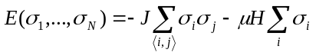 (1)
where ⟨i, j⟩ refers to nearest-neighbor interactions and particle spins σ_{i} have value ±1.
The internal energy E of the electrical Ising model has a slightly different but analogous form:
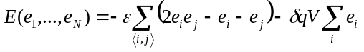, (2)
where particle states e_{i} may be 0 or 1. Oppositely aligned neighbors increase E by an interaction energy ε. A change in e_{i} from 0 to 1 moves a small “gating” charge δq, thereby decreasing the field energy by δqV. Absent an applied field V, the internal energy of the Ising model increases in increments of 2ε from 0 to 2Nε, assuming periodic boundary conditions. The order parameter q, which serves as a reaction coordinate, is the total charge displacement:
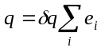, (3)
whose value ranges from 0 to Nδq. The electrical Ising model can be easily mapped into the magnetic model using the transformations: σ_{i} ↔ 2e_{i} – 1, 2J ↔ ε, 2μ ↔ δq, and H ↔ V, where J is the coupling energy, μ is the magnetic moment, and H is the magnetic field. Therefore all the results discussed here are valid also for the magnetic Ising model.
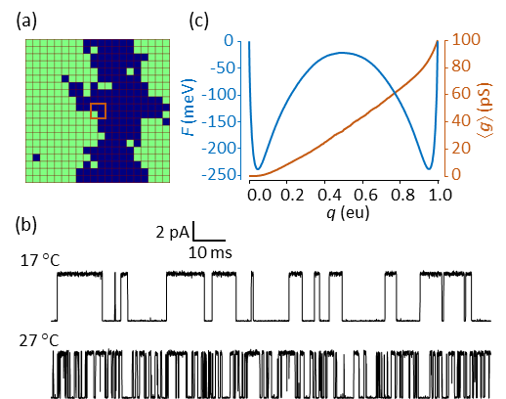
FIG. 1. (a) 20 x 20 electrical Ising model. Green cells indicate activated particles. In order to simulate “ionic” currents i(t) qualitatively similar to those observed in ion channels, we introduced a central “pore” comprised of a 2 x 2 particle sub-grid (brown square) whose instantaneous conductance g is a function of the sub-grid configuration, with each of the four inscribed particles contributing a partial conductance of 25 pS (picosiemens) if activated. (b) Monte Carlo simulations of the Ising model “pore” at two temperatures, with ionic current governed by Ohm’s law: i = g(V – V_{rev}). Simulation parameters: V = 0 mV; V_{rev} (reversal potential) = –60 mV. The current was digitally filtered as previously described (Sigg, 2013) with a cutoff frequency of 10 kHz and sampling rate 100 kHz. Observed noise was entirely due to “pore” current fluctuations, with no noise added. (c) 1D free energy landscape F(q) and mean conductance ⟨g(q)⟩ obtained from microscopic time-averaging over a 0.4 s simulation at 17 °C. The abbreviation “eu” refers to fundamental units of electric charge.
Simulated trajectories of the electrical Ising model with a centrally-conducting “pore” are qualitatively similar to laboratory-generated single-channel currents from ion channels (Fig. 1b). Both demonstrate stochastic switching between distinct macrostates. We made no attempt at a realistic depiction of channel gating; instead, the aim was to test whether slow barrier kinetics were preserved after coarse-graining the kinetic Ising model into a diffusion landscape. There are practical advantages to using the Ising model rather than performing detailed molecular dynamics simulations of a protein such as an ion channel: (1) There is no inertial memory in Ising dynamics, obviating the need for a time-dependent diffusion coefficient; (2) Particle interactions are nearest-neighbor and regular, allowing rapid calculation of kinetics and long-term trajectories; (3) The Ising system is bounded in E, q, and N, and its thermodynamics can be fully described using the microcanonical ensemble; (4) Microscopic rates can be expressed as functions of E and q, and thus averaged over the microcanonical ensemble; (5) Coarse-grained kinetics are expressible in the form of a master equation that can be solved numerically.
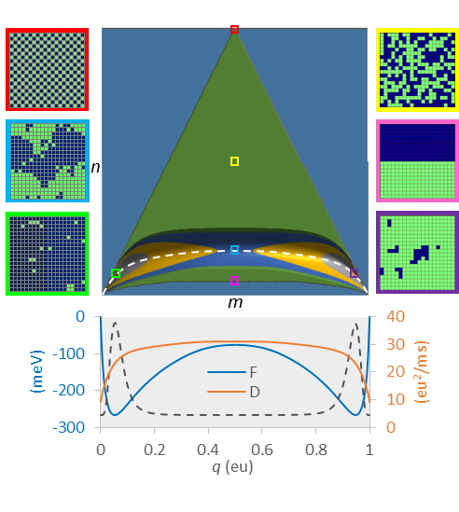
FIG. 2. Course graining the 20 x 20 electrical Ising model (N = 400). The green triangle is the set of all microcanonical mesostates (= 73,448) on the (m, n) grid. The 3D contoured region at the base of the triangle is the reaction pathway comprised of a reduced number of mesostates (= 22,149) constrained by F < F_{max}, for conditions: T = 22 °C, V = 0 mV, and F_{max} = 150 meV. The maximum vertical span (bandwidth) of the reaction pathway is 68 cells at the saddle point. The dashed white line is the mean energy ⟨E⟩. Representative microscopic configurations are shown on both sides for: maximum energy (red); maximum entropy (yellow); saddle point (blue); minimum transition state energy (pink); minimum free energy in state 1 (green), and in state 2 (purple). Projected 1D landscapes F(q) and D(q) are plotted at bottom, along with the 1D equilibrium probability distribution P(q) (dotted line).
The coarse-graining procedure is illustrated in Fig. 2. Representative examples of the 2^{N} microscopic configurations are shown for a 20 x 20 Ising model (N = 400). The microscopic dynamics for the complete state space are governed by a master equation, albeit an impossible one to solve due to the vast number of microstates. We binned the microstates onto a more manageable N x N mesoscopic grid of the microcanonical density of states Ω(q, E) (Pleimling and Behringer, 2005). Each mesostate (q, E) can be described by an integer pair (m, n), where q = mδq and E = 2nε. The mesoscopic state space of the Ising model is triangular with a concavity at the base. The height of the concavity is 2N^{½}ε, giving rise to the well-known symmetry-breaking properties of the 2D Ising model. The purpose of coarse-graining was to construct a mesoscopic master equation whose smallest non-zero eigenvalue is the macroscopic relaxation rate.
Since simulations representing reality must be run at constant temperature and voltage, a free energy landscape F(T, V) was constructed from Ω_{mn}, the integer representation of Ω(q, E).
. (4)
F_{nm} is a potential of mean force (pmf) on the (m, n) grid, but for sufficiently large N, it is effectively a smooth function of q and E. At positive values of ε, only the lower portion of the triangle is appreciably populated (paramagnetism in the traditional Ising model). In order to limit the mesoscopic (m, n) states to a manageable number, we established a cut-off value F_{max} chosen to be at least 6 kT greater than the saddle point energy.
A second level of coarse-graining involved projecting the 2D landscape F_{nm}(T, V) onto a 1D pmf F_{m}(T, V) shown at the bottom of Fig. 2. The free energy projection is defined by:
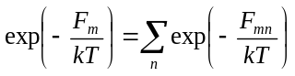. (5)
The 1D pmf has N + 1 states. The 1D and 2D pmfs provide exact thermodynamic information, though quantities derived from the 1D landscape are limited to functions of q. From the 2D landscape we can, using Boltzmann averaging, obtain heat capacities for different ensembles (Fig. 3a); these are less peaked than for the infinite-particle Onsager solution around their respective “critical” temperatures. Both 1D and 2D pmfs yield the plot of mean charge displacement ⟨q⟩ versus V, which steepens around V = 0 at low temperatures (Fig. 3b).

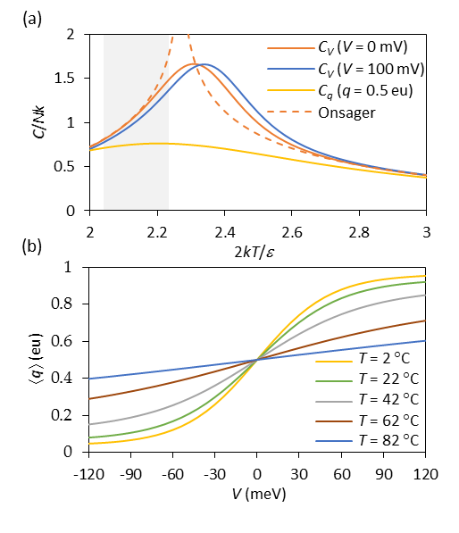
FIG. 3. (a) Heat capacities C of the 20 x 20 Ising model for constant V and q, as a function of temperature. The dotted curve is the exact Onsager solution for an infinite grid (Toda et al., 1992). The shaded region denotes the physiological range of T from 10 °C to 40 °C. (b) Mean charge displacement ⟨q⟩ versus V for indicated temperatures.
- Microscopic rates
In order to study dynamics we needed a model for microscopic rates. These are constrained by detailed balance:
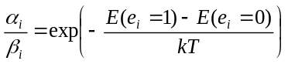, (6)
where α_{i} and β_{i} are the forward and backward rates associated with the activation of the i^{th} particle. We assumed barrier kinetics of the form:
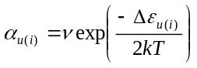, (7a)
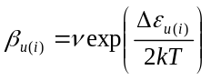 , (7b)
where ν is the pre-exponential factor and the energy of activation Δε depends on the number u(i) of activated neighbor particles, as follows:
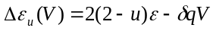 . (8)
There is nothing unique about our choice of microscopic rate constants. A different choice attributed to Glauber (Glauber, 1963) could be used if one wishes to prevent the microscopic rate from exceeding ν.
C. Mesoscopic rates
There are ten mesoscopic rate constants, one for each combination of u (0…4) and e (0, 1). These describe the ten cardinal transitions (five forward and five backward) available to a given (m, n) state (Fig. 4). The mesoscopic rates have the form: a_{kk′} = ⟨r_{kk′}⟩α_{u} (forward) and b_{k′k} = ⟨r_{k′k}⟩β_{u} (backward), where ⟨r_{kk′}⟩ is the transition frequency from mesostate k = (m, n) to k′ = (m′, n′). Detailed balance in the microcanonical ensemble is described by ⟨r⟩_{kk′} g_{k} = ⟨r⟩_{k′k} g_{k′}. Averaging the microscopic rates on the mesoscopic scale is the critical step in coarse-graining. With the exception of the smallest square Ising scheme (N = 4), the mesoscopic rate constants a_{kk′} and b_{k′k} are Boltzmann-weighted averages over multiple microstates. Not every cardinal direction is accessible to a particular microstate, even if other microstates within the same mesostate can undergo the move. We’ll revisit this essential point in the Discussion section.
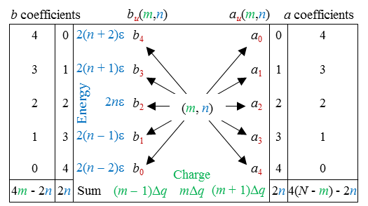
FIG. 4. Cardinal transitions from an (m, n) mesostate. Relationships between cardinal rates are expressed in the outer columns, where rate constants multiplied by a and b coefficients sum to the expressions on the bottom row, representing relationships between the cardinal rates. Detailed balance accounts for additional constraints between opposing rates, expressed as: a_{u}/b_{u} = exp(−Δε_{u}/kT).
Projection of the 2D rate constants onto the m axis through Boltzmann averaging yielded the 1D rates a_{m} and b_{m}, or in continuous notation a(q) and b(q). In 1D, detailed balance assumes the form: a(q)exp(−F(q)/kT) = b(q + δq)exp(−F(q + δq)/kT). The 1D diffusion coefficient D(q) was obtained from the Brownian motion expression 2D(q) = [a(q) + b(q)]δq². The 1D dynamics can be expressed either through a_{m} and b_{m}, from which a master equation can be constructed, or through the landscape variables F(q) and D(q), which can be inserted into a Langevin equation. The two representations are equivalent for large systems. But because the Langevin equation is an approximation to the master equation, valid only for small δq, we regularly used the master equation for our calculations. Even so, predictions from Langevin simulation were not very different for the model sizes considered (N ≥ 256).
Apart from coarse-graining in the microcanonical ensemble, we employed a second method for determining the 1D landscape variables F(q) and D(q) (or equivalently, a_{m} and b_{m}), namely by simulating the kinetics of the “native” Ising model under conditions of constant T and V and obtaining time averaged quantities. For the 1D Ising representation, we obtained the complete F(q) by evaluating −kTlnP(q) over a very long trajectory, where P(q) is the time-averaged probability of being in the state q. The boundary condition F(0) = 0 determined the vertical displacement of the free energy. A faster method would be to use umbrella sampling and align overlapping segments of F(q) (Chandler, 1987), but the advantage of a long unbiased run with numerous barrier crossings is it allowed us to determine the exact transition rate constant from first passage times, as described in the next section (Macroscopic rates).
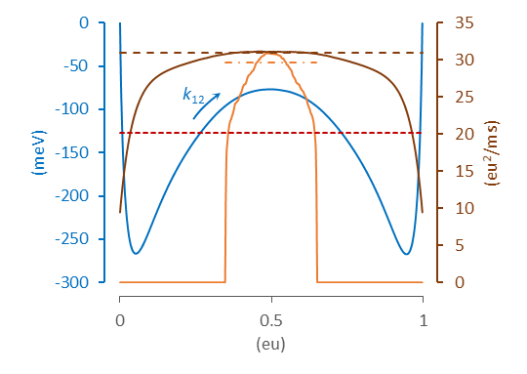
FIG. 5. Parallel representations for D. The diffusion landscape D(q) obtained from the 1D master equation is shown as the solid brown line. The combination of D(q) and the free energy landscape W(q) (blue line) yields a forward rate constant k_{12 [1D]} = 0.921 kHz. The spatially independent value of D (dashed brown line) predicting the identical rate constant has a value (30.9 eu²/ms), very close to the peak value of D(q). High-bandwidth simulations performed with a sharp umbrella window in the barrier region (q = 0.35 eu to 0.65 eu) yielded an abbreviated D(q) (solid orange line; averaged from 500 traces). Nyquist’s theorem applied to i_{g} fluctuations measured from the same data set predicted D = 29.1 eu²/ms (dot-dashed orange line). By comparison, the value of constant D consistent with the exact rate constant (k₁₂ _{[exact]} = 0.598 kHz) obtained from long-run native simulations is only 20.1 eu²/ms (red dotted line). Model parameters were: N = 400, T = 22 °C, V = 0 mV. The cut-off frequency for i_{g} simulations using a digital Gaussian filter was: f_{c} = 5 x 10⁵ kHz. The filter bandwidth is given by B = 1.064 f_{c} (Crouzy and Sigworth, 1993).
In our simulations, 1D ensemble and time-averaged quantities superimposed neatly, confirming ergodicity. A caveat to ensemble averaging is that it applies only to canonical variables that are functions of q and E. Obtaining means and other moments of non-canonical variables, such as the invented “pore” conductance featured in Figure 1, require time-averaging. Using time-averaging, the diffusion constant D(q) can be obtained from the mean forward and backward rates as described above. From a practical standpoint, the macroscopic rate is essentially determined by the value of D at the barrier peak (Fig. 5), which reduces the necessity of obtaining the complete diffusion landscape. This independence of the rate constant to the shape of D(q) comes about if the free energy barrier is sufficiently large (≥ 6 kT) that basin states thermalize rapidly compared to outflow over the barrier.
A completely independent method for determining D is to simulate short (1 ms) segments of large-bandwidth trajectories within a 30% window centered on the barrier peak, and measure fluctuations in the filtered impulses of charge movements i_{g} = dq/dt, the aggregation of which is known as “gating” current in the ion channel literature, and is essentially shot noise (Sigg et al., 1999). After applying Nyquist’s current theorem: 4kTB/R = ⟨i_{g}²⟩, where R is resistance, and B is the recording bandwidth related to the cut-off frequency of a digital Gaussian filter through B = 1.064 f_{c} (Crouzy and Sigworth, 1993), the “Nyquist” value of D can finally be obtained using the Einstein relation DR = kT. The use of Nyquist’s theorem in this context is similar to other deployments of the fluctuation-dissipation theorem in obtaining the diffusion coefficient governing Brownian motion across a free energy landscape (Straub et al., 1987) (others).
- Macroscopic rates
The third and final level of kinetic coarse-graining reduces the kinetic Ising model to a pair of forward (k₁₂) and a backward (k₂₁) rate constants. Starting with the 1D and 2D free energy landscapes, we computed k₁₂ and k₂₁ using three methods: (1) eigenvalue analysis; (2) mean first passage time (MFPT); and (3) Monte Carlo simulation. In the eigenvalue method, mesoscopic rates a, b were tabulated in a rate matrix Q constructed to satisfy the master equation dp/dt = pQ, where p(t) is the row vector of state probabilities (Sigg et al., 1999). The first non-zero eigenvalue of Q equals the sum k₁₂ + k₂₁. When necessary, the ratio k₁₂/k₂₁ was obtained using detailed balance so individual rates could be determined. This is necessary only if V ≠ 0; otherwise, symmetry demands k₁₂ = k₂₁. The MFPT method involved truncating Q at q = q₂, where q₂ is the free energy minimum of the second basin state, thereby creating an invertible matrix Q′. The mean first passage time (MFPT) from q < q₂ to the absorbing boundary q₂ was obtained by solving Q′τ = u (Van Kampen, 1992), where τ is the column vector of MFPTs τ(q → q₂) and u is the unit vector. The quantity 1/τ(q₁→ q₂), where q₁ marks the minimum free energy in state 1, is an accurate estimate of the forward rate constant k₁₂ for sufficiently large barriers (≥ 6 kT) (Reimann et al., 1999). In the last (Monte Carlo) method, we constructed a coarse-grained master equation for the 2D mesoscopic rates on the (m, n) grid, and one for the projected 1D rates a_{m} and b_{m}, from which long (4 sec) Monte Carlo simulations generated exact first passage times between q₁ and q₂, the inverse averages of which yielded k₁₂ and k₂₁.
- Native Monte Carlo simulation
A continuous-time Monte Carlo algorithm for simulating the native (non-coarse-grained) model at constant T and V was used to obtain exact first passage times from q₁ to q₂. We obtained the inverse MFPT from thousands of transition events and used this value as the gold standard for k₁₂, which was compared to results from coarse-grained models. We could not verify the accuracy of native Monte Carlo simulation using independent methods, as we did above for the 1D and 2D simulations. However, consistent outcomes were obtained using several “good” pseudorandom number generators (Fig. 6), suggesting the calculations were reliable.
III. NUMERICAL METHODS
The majority of Monte Carlo simulations and analysis routines were run using customized software written in C. For each set of environmental conditions (N, T, V, F_{max}), six simulations ran simultaneously, comprising a single experiment. Each run generated the following: (1) the density of states Ω and transition frequencies ⟨r⟩; (2) 1D and 2D potentials of mean force and rate constants in the (N, T, V) ensemble; (3) simulated trajectories of the native process and coarse-grained master equation simulations in 1D and 2D; (4) MFPT for native, 1D, and 2D Monte Carlo simulations using exact first passage times from ~10⁴ events, and for 1D and 2D master equations using the Q′ method; and (5) eigenvalue analysis for 1D and 2D master equations. Output parameters for each experiment were expressed as their mean and standard error. We chose as the reference model the 20 x 20 Ising grid (N = 400) with the following parameters: T = 22 °C; V = 0; ε = 24 meV; q_{max} = 1 eu; and ν = 5 x 10⁴ kHz. Additional experiments with different T, V, and N were run to determine environmental and grid size effects on the forward rate constant. A total of 15 experiments were performed. The values of ε, δq = q_{max}/N, and ν were held constant across experiments.
- Random number generators
We tested several pseudorandom number generators to address the possibility of biased sampling. These were: (1) Numerical Recipes© long-period L’Ecuyer generator with Bays-Durham shuffle (ran2) (Press et al., 1992); (2) Intel® MKL Library SIMD-oriented Fast Mersenne Twister (FMT) (Saito and Matsumoto, 2008); (3) Intel® MKL Library multiplicative congruential generator (MCG) (L’Ecuyer, 1999a); and (4) Intel® MKL Library combined multiple recursive generator (MRG) (L’Ecuyer, 1999b). Of the four generators, the MCG algorithm yielded outlying outcomes and greater variability than the other three (Fig. 6), and is not recommended for use in our model. Most simulations employed the ran2 algorithm. In a small number of cases involving large barriers where the performance of the random number generator was in doubt (for example, Fig. 6b), repeating the simulations using the FMT and MRG algorithms helped to confirm the results.
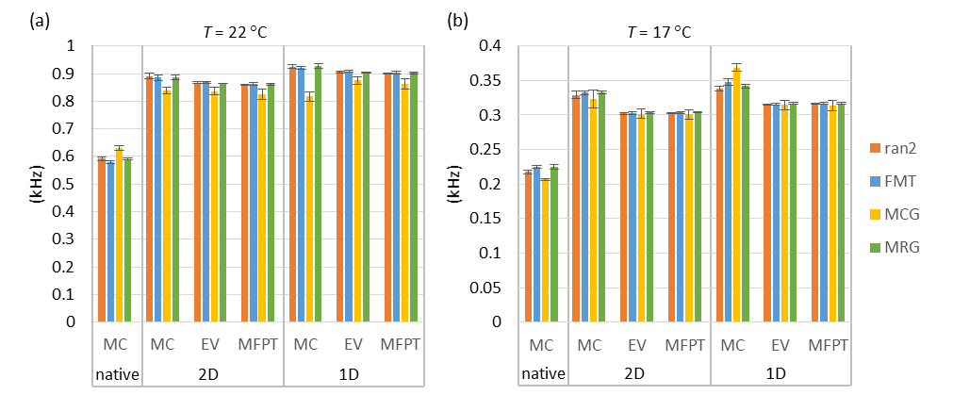
FIG. 6. Forward rate constant estimates (mean ± s.e., n = 6) from different methods (MC = Monte Carlo, EV = eigenvalue analysis, MFPT = mean first passage time) as a function of pseudorandom number generator. (a) Reference model; T = 22 °C. (b) Temperature lowered to 17 °C, which increased the barrier height and led to a discrepancy between Monte Carlo and the other two methods (EV and MFPT). Results were consistent between generators except in the case of the multiplicative congruential generator (MCG), which demonstrated lower accuracy and precision compared to the other three generators.

- Computing mesoscopic rates
The Metropolis Monte Carlo (MMC) method was used to compute average rates in the microcanonical distribution. Applying traditional MMC for infinite T and zero V allows every trial move to be accepted, in principle yielding the microcanonical ensemble. However, the large entropy gradient makes this algorithm impractical for all but the smallest systems, so a bias potential ω_{k} was applied to “flatten” the gradient and allow uniform sampling over all k = (m, n) mesostates. The 1/t variant of the Wang-Landau algorithm with endpoint refinement parameter F_{final} = 10⁻⁶ was used to rapidly obtain lnω_{k} (Belardinelli and Pereyra, 2007). MMC was then implemented by picking a random particle to flip, and after determining the locations of the current state k and the trial state k′ on the (m, n) grid, applying the following acceptance criterion for the k → k′ transition:
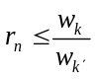, (9)
where r_{n} is a uniform random number from 0 to 1. For each discrete time point s, the ten cardinal rates a_{u} and b_{u} were determined by summing microscopic rates over all particle transitions. For example, if nine out of N particles contribute to the backward transition (u, v) → (u – 1, v + 2), then the instantaneous rate b₄(s) would be assigned the value 9β₄, where β ₄ is the corresponding microscopic rate (Eq. 7b). The starting configuration for each simulation run was chosen randomly. Following an equilibration period of 2 x 10⁶ time points, time-averaged forward rates were obtained over the next 2 x 10¹⁰ time points using the following formula:
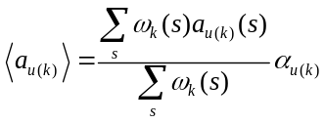, (10)
with a similar expression for reverse rates ⟨b_{u(k)}⟩. The ratio of sums in Eq. 10 is the mean transition frequency ⟨r_{kk′}⟩, which can be rewritten: ⟨r_{u(k)}⟩_{a}, and for the reverse transition: ⟨r_{u(k)}⟩_{b}. The microcanonical density of states was obtained from:
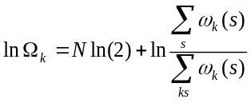. (11)
The density of states Ω_{k} and rate factors ⟨r_{u(k)}⟩_{a} and ⟨r_{u(k)}⟩_{b} were stored as N x N matrices lnΩ, A_{u}, and B_{u} (Fig. 7). These eleven matrices are correlated and could theoretically be stored as five independent matrices (Fig. 4), but to avoid the possible increase in sampling error this was not done. It should be emphasized that, like lnΩ, A_{u} and B_{u} are statistical matrices that depend only on N. In order to calculate mesoscopic rate constants as a function of environmental constraints: T, V; and model parameters: ε, q_{max}, and ν, we used: a_{u(k)} = ⟨r_{u(k)}⟩_{a}α_{u} and b_{u(k)} = ⟨r_{u(k)}⟩_{b}β_{u}, employing Eqs. 6 and 7 for the microscopic rates α_{u} and β_{u}.
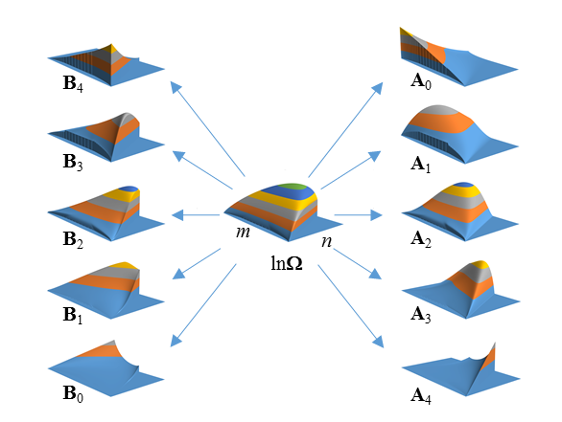
FIG. 7. Density of states (lnΩ) and cardinal rate (A, B) matrices for 20 x 20 Ising model. Vertical axes are not to scale. The n-axis was cut off at n = 254 due to limitations of the plotting software.
- Computing macroscopic rates
In order to compute macroscopic rates k₁₂ and k₂₁, a rate matrix Q was constructed. The upper diagonal terms of Q contained forward rates a_{u(k)} (2D) or a_{m} (1D), and lower diagonal terms contained backward rates b_{u(k)} (2D) or b_{m} (1D). Diagonal terms were assigned so that all row entries summed to zero, satisfying the master equation dp/dt = pQ. Macroscopic rate constants were then calculated from Q using the methods (Monte Carlo, eigenvalue, and MFPT) detailed in the Theory section.
A practical difficulty arose from the large size of Q, particularly for the 2D representations. From the N² possible 2D states, somewhat less than half are theoretically accessible (Fig 2). In the case of the 20 x 20 Ising model, the 2D size of Q would be 73,448 x 73,448. The number of accessible states l can be substantially reduced by establishing a free energy cutoff F_{max}, above which visitation by an unbiased Monte Carlo trajectory would be negligible. To avoid artificially constricting the barrier region, which would underestimate transition rates, F_{max} was chosen to be at least 150 mV higher than the saddle point energy. Further size reductions in Q were achieved by repacking it into band form. We numbered the mesostates in column order of increasing m and n(m), resulting in a maximum bandwidth d for the main diagonal equal to the width of the saddle point for the energy-capped landscape. The banded Q dimensions were l x 2d+1. Typical values of l and d for the 2D landscape were ~20,000 and ~70. By taking advantage of eigenvalue and linear routines designed for band matrices, macroscopic rates could be calculated in short order. The eigenvalue and mean first passage time calculations were easily adapted for 1D calculations, where Q is tridiagonal (d = 1) and l = N + 1.
- Macroscopic rate constants from Monte Carlo simulation
A continuous-time Monte Carlo method (Sigg et al., 1999) was used to simulate the kinetics of both native and coarse-grained versions of the Ising model. The continuous-time method avoids the shortcomings of the Metropolis algorithm, which is not suitable for kinetics. In simulating the native Ising model, which is governed by a master equation, the state-dependent flip rate (α_{i} or β_{i}) for every particle i was determined at each step, and particle rates were summed in the forward (∑α_{i}) and backward (∑β_{i}) directions. The time between transitions was randomly obtained from −lnr_{n}/r, where r is the combined transition rate ∑α_{i} + ∑β_{i}, and the particle to be flipped was chosen with a separate random draw using weights proportional to each particle’s activation or deactivation rate. The process was repeated until 4 seconds of simulation time was completed. Essentially the same algorithm was used to simulate the coarse-grained master equations in 1D and 2D governed by Q.
IV. RESULTS
- Rate constants from Monte Carlo Simulation
First passage times from ~10⁴ macroscopic transitions simulated from native dynamics enabled us to compute the exact rate constants k₁₂ and k₂₁. We consider from this point only the forward rate k₁₂ since, apart from two experiments where V ≠ 0, the opposing rates are equal. Filtered Monte Carlo trajectories on a time scale that includes multiple transition events clearly demonstrate the difference in rate constants between native and coarse-grained dynamics, readily visible by eye (Figs. 8a, 8b). However, very precise values of k₁₂ could be obtained by calculating the mean dwell times within the first basin (τ₁). We equated τ₁ with the MFPT from q₁ to q₂. The two-state approximation predicts an exponential distribution of dwell times. Figure 8c shows the distributions from native, 1D, and 2D Monte Carlo simulations. A Sigworth-Sine transformation was applied to the dwell time distribution in order to generate uniform residuals for fitted curves (Sigworth and Sine, 1987). A practical feature of the Sigworth-Sine plot is that the transformed distribution peaks at τ₁.
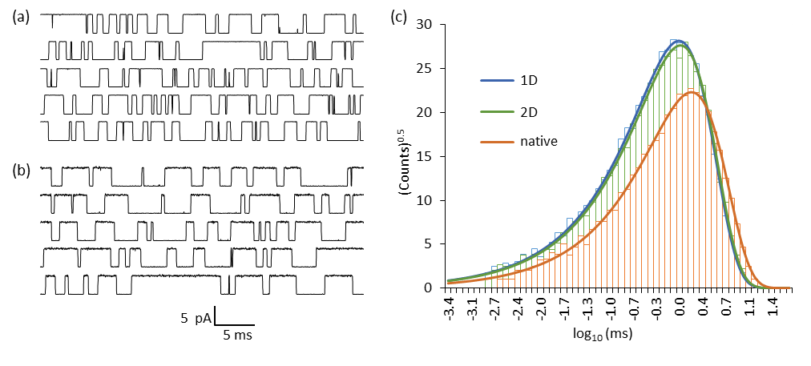
FIG. 8. Dwell time analysis. (a) Filtered “ionic” current trajectories simulated from the 1D master equation. (b) Same as (a) except without prior coarse-graining (native dynamics). The reference Ising model was used in both simulations; f_{c} = 10 kHz. (c) Sigworth-Sine plot of binned forward passage times between q₁ and q₂ demonstrates fewer overall events and a longer average dwell time for native dynamics compared to 1D and 2D dynamics.
It is apparent from Fig. 8 that for both the native and coarse-grained models, the binned dwell times faithfully followed the theoretical distribution across roughly four orders of magnitude. The macroscopic two-state approximation for small (N ~ 400) kinetic Ising systems is evidently very good across relevant time scales. Even allowing for binning error, fitting the Sigworth-Sine plot to the dwell time distribution yielded a τ_{fit} that was very close to τ₁ (Table I).
TABLE I. Forward Mean First Passage Times from Monte Carlo simulation.
 | Native | 2D | 1D
counts | 6,776 | 10,397 | 10,791
τ₁ (ms) | 1.672 ± 0.020ª | 1.145 ± 0.011ª | 1.086 ± 0.010ª
k₁₂ (kHz) | 0.5982 ± 0.0073^{b} | 0.8735 ± 0.0085^{b} | 0.9210 ± 0.0088^{b}
τ_{fit} (ms) | 1.675 | 1.146 | 1.088
ªstandard error (τ₁) = τ₁/counts^{½} (property of exponential distribution).
^{b}standard error (k₁₂) = (k₁₂/τ₁)s.e.(τ₁).
The coarse-grained representations (1D and 2D) predicted significantly smaller values of τ₁ than the native process, giving rise to a roughly 50% larger k₁₂ value. The 2D landscape yielded a marginally more accurate result than the 1D landscape. These are the major findings of our study.

- Comparing numerical methods
We checked the Monte Carlo estimate for k₁₂ against the eigenvalue and MFPT methods for the 1D and 2D representations. There was generally excellent agreement between the three calculations. There were some mild discrepancies in two circumstances where the PMF barrier was quite large (T = 17 °C and N = 484). The Monte Carlo-derived rate constants for these larger barriers were slightly larger compared to the other two methods (for example, Fig 6b). However, even in these special cases, the Monte Carlo outliers were not enough to significantly alter the mean value of k₁₂ taken from all three methods.
- Rate constants as a function of N, T, and V
The dependence of k₁₂ on structural and environmental variables N, T, and V can be predicted from the shapes of 1D energy and diffusion landscapes shown in Fig. 9. Reactive rate theory predicts that k₁₂ should decrease exponentially with forward barrier height ΔF and increases linearly with maximum D, with relative curvatures around both the reaction basin (state 1) and the barrier making minor contributions (Sigg, 2014). The value of ΔF increased with increasing N and decreased with increasing T and V. The relevant peak value of D(q) increased substantially with increasing N, more slowly with increasing T, and was negligibly dependent on V.
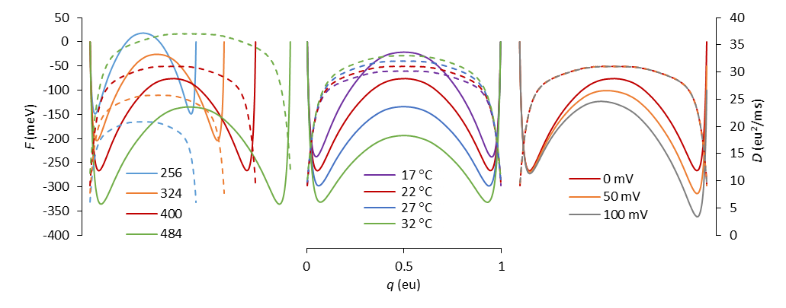
FIG. 9. Free energy (solid lines) and diffusion (dashed lines) landscapes as a function of model parameters (left plot, N; middle plot, T; right plot, V). The red curves correspond to the reference model (N = 400; T = 22 °C; V = 0 mV). Landscapes were calculated from ensemble averaged mesoscopic rate constants, but time averaging of Monte Carlo trajectories yielded practically identical results.
We wanted to know if the overestimation of the exact macroscopic rate constant due to coarse-graining was consistent across all environmental conditions, so we compared the Monte Carlo-derived values for the native process with the averages of Monte Carlo, eigenvalue, and MFPT estimates for the 1D and 2D models at different N, T and V. The results are shown in Fig. 10.
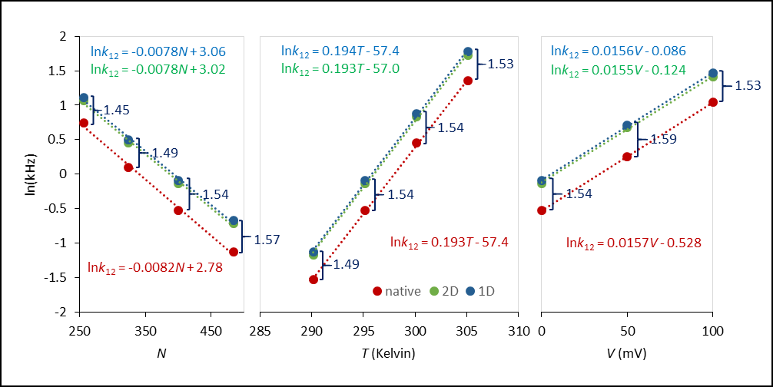
FIG. 10. Linear regression analysis in the semilog plot of forward rate constants with respect to the same environmental conditions as in Fig 9. The native rate constants were calculated as the inverse means of Monte Carlo first passage times from q₁ to q₂, as described in the text. The 1D and 2D rate constants were averaged from their respective Monte Carlo, MFPT, and eigenvalue calculations. Error bars from six experiments are not visible because they are located within the markers. The linear regression equations are color-matched to their respective fitted data. The ratios of 1D to native rates are written in dark blue.
The results show that for all conditions, the coarse-grained (1D and 2D) estimates of forward rate constants remained about 50% greater than the native rate constant, with 1D rates again slightly greater than their 2D counterparts. The approximate 3:2 ratio was consistent, though there was a small tendency towards larger ratios with increasing system size (N). Linear fits describing the relationships lnk₁₂ = cX + d, with X representing either N, T, or V, resulted in nearly identical slopes c for native, 1D, and 2D calculations. These slopes have physical significance. From the lnk₁₂ vs. N plots, we determine that every added particle increases the barrier by 0.2 meV. The lnk₁₂ vs. T and lnk₁₂ vs. V plots are consistent with an activation charge of 0.4 eu and activation energy of 1450 meV.
The findings so far suggest that for constraints roughly within the physiological range, the overestimation of rate constants caused by coarse-graining could be corrected using a constant factor of 1.5. The small difference between 1D- and 2D-derived values of k₁₂ can be attributed to the energy-directed curvature in the 2D reaction pathway (Fig. 2). There is presumably some dynamic information lost when the 2D landscape is projected onto a 1D pmf. We wanted to see if there was a similar consistency in the values of D obtained from Nyquist analysis. Earlier we demonstrated that in the reference model, the Nyquist value of D obtained from large-bandwidth “gating” currents slightly underestimated the peak value of D(q) (Fig. 5). In order to determine whether the two values were indeed correlated, we ran further simulations varying the values of T and N. The means and standard deviations of D(Nyquist) divided by D(q) for the seven experiments in Fig. 11 was 0.952 ± 0.004. These results were independent of the bandwidth B, provided the filter cut-off frequency was large enough to avoid suppressing the high frequency components of the shot noise. The 30% simulation window used was optimal for obtaining the largest value of D. A smaller window lead to edge effects, and a larger window included the lower D regions on the sides of the barrier. The constancy of the D-ratios suggests that the Nyquist value closely follows the coarse-grained estimates of D. The Nyquist value is 95% of the maximum D(q), in contrast to 66% for D corresponding to the exact rate constant (Fig. 5).
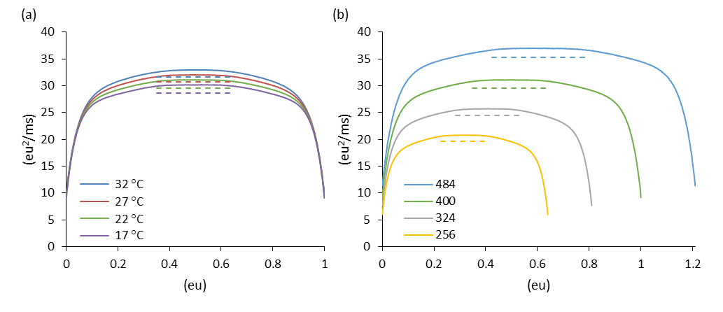FIG. 11. Diffusion landscapes as a function of (a) T; (b) N. Dashed lines indicate the Nyquist value of D obtained from windows between 0.35 to 0.65 of maximum q; f_{c} = 5 x 10⁵ kHz. The reference model (N = 400; T = 22 °C; V = 0 mV) corresponds to the green curves.
V. DISCUSSION
The inspiration for this study came about after one of us (DS) attempted to construct a 1D diffusion landscape for the kinetic Ising model. Efforts to compute the correct native transition rate from the coarse-grained landscape failed regardless of which method (Monte Carlo, Langevin, MFPT, or eigenvalue) was used. The problem was originally thought to lie with the 1D projection along q, so we expanded the landscape to a 2D representation in q and E. This provided a complete thermodynamic solution to the square Ising problem, but yielded only a small improvement in the value of the rate constant. It became clear the main culprit was the manner in which microscopic rates were averaged at the mesoscopic level. What works well for thermodynamics does not necessarily work for kinetics.
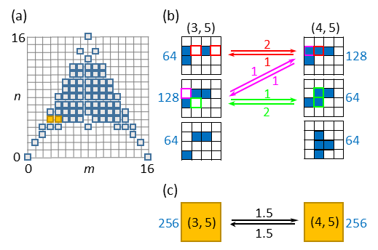
FIG. 12. (a) Mesoscopic (m, n) grid for the 4 x 4 Ising model. The (3, 5) and (4, 5) states are colored yellow. (b) Microstate sub-groups compatible with the (3, 5) and (4, 5) states. Blue cells are activated. The number of microstates (Ω_{i}) in each sub-group are shown adjacent to typical configurations. Allowed transitions between sub-groups are labeled with a frequency factor. (c) The mesoscopic transition scheme, where state-averaged frequency factors are the ⟨r⟩ rates discussed in the Theory section.
Our methods do not reveal the precise source of error in coarse-graining, but a clue may be found by analyzing in detail a specific transition in a smaller Ising square (Fig. 12). The (3, 5) ↔ (4, 5) transition in the 4 x 4 Ising model (N = 16) moves δq of charge but leaves the energy unchanged. The (3, 5) and (4, 5) mesostates both contain Ω = 256 microstates, and both are split into three sub-states (i), each with Ω_{i} microstates. Two of the three sub-states experience transitions to the opposing mesostate, contributing to the mean rate constant in proportion to the product of Ω_{i}/Ω and a microscopic frequency factor (the number of transition paths available to the sub-state). The averaged product is the mesoscopic frequency factor ⟨r⟩ discussed in the Theory section. The third sub-group, comprising a quarter of microstates in each mesostate, does not participate in the reaction at all because there are no transition paths available to it. This sub-group does not contribute to the mean rate, and should the system find itself in one of its microstates, a path to a different energy state must be taken. This suggests that for the native process, trajectory pathways are on average a bit longer than predicted by the coarse-grained representation. We conjecture that the additional pathway length is responsible for the slower rates in the native process.
In proteins, there is the concept of frustration, in which trajectories become trapped in blind end states of varying energy depth, leading to low-temperature power-law distributions in reaction rates (Frauenfelder et al., 1991). The simple Ising process does not experience frustration in the same way, since movement in either direction of the order parameter q is always possible, but the inaccessibility of some micro-configurations pathways could be viewed as a minor form of frustration.
One may question whether mesoscopic averaging using the microcanonical grid is an optimal method for coarse-graining the kinetic Ising model. An argument in favor of the microcanonical approach is that it completely specifies N-particle thermodynamics for canonical variables as a function of T and V. We chose an expression for the microscopic rate constant that satisfied the canonical requirement of q- and E-dependency, but whose averaging apparently depended on microscopic transition pathways in a way that thermodynamic averaging does not. The fact that microcanonical coarse-graining overestimates the exact transition rate constant in Ising kinetics suggests it is an “incorrect” approach, though one could argue that it is at least a rational one, since there was no a priori reason to suggest it would fail. The coarse-grained master equation is closely related to a free energy-diffusion landscape, since in 1D the kinetic outcomes of [a_{m}, b_{m}] and [W(q), D(q)] representations are equivalent for large enough N. This should also be true for higher dimensional landscapes.
The landscape approach is typical for protein studies, where sampling of the configuration space using molecular or Langevin dynamics can be used to generate a potential of mean force (Harpole and Delemotte, 2017). Fluctuation analysis combined with umbrella sampling can be used to generate a diffusion constant that may be spatially dependent or even have memory for past events (Straub et al., 1987). We attempted to use a similar fluctuation analysis of native Ising dynamics using Nyquist’s theorem to measure D at the barrier peak, but the results are more compatible with the coarse-grained value of D than with the effective native value (Fig. 5 and Fig. 11). This is counterintuitive since the shot noise measurements that give rise to the Nyquist value are based on the native process, yet the Nyquist value is very close to the coarse-grained value of peak D. Since the Nyquist formula is based on the fluctuation-dissipation theorem (ref), the findings suggest a breakdown of the fluctuation-dissipation theorem in the kinetic Ising model.
Given our results, it is conceivable that kinetic coarse-graining through the use of ensemble-averaged rate constants will fail for any complex system with inter-particle interactions. In the case of the Ising model, it is encouraging that the approximate 3:2 ratio of calculated to “native” rates appears fairly constant across “physiological” conditions. Thus, for practical purposes, the kinetics has of our toy model has been “solved”, provided one employs the correct scale factor. It remains to be seen whether such a scale factor exists for other finite networks of interacting particles, such as proteins.

ACKNOWLEDGMENTS

REFERENCES
Belardinelli, R.E., and V.D. Pereyra. 2007. Fast algorithm to calculate density of states. Phys. Rev. E. 75:46701. doi:10.1103/PhysRevE.75.046701.
Best, R.B., and G. Hummer. 2010. Coordinate-dependent diffusion in protein folding. Proc. Natl. Acad. Sci. 107:1088–1093. doi:10.1073/pnas.0910390107.
Chandler, D. 1987. Introduction to Modern Statistical Mechanics. 1st ed. Oxford University Press. 288 pp.
Crouzy, S.C., and F.J. Sigworth. 1993. Analysis of nonstationary shot noise p ( t ) Q ,. 64:53–59.
Frauenfelder, H., S. Sligar, and P. Wolynes. 1991. The energy landscapes and motions of proteins. Science (80-. ). 254:1598–1603. doi:10.1126/science.1749933.
Glauber, R.J. 1963. Time‐Dependent Statistics of the Ising Model. J. Math. Phys. 4:294–307. doi:10.1063/1.1703954.
Harpole, T.J., and L. Delemotte. 2017. Conformational landscapes of membrane proteins delineated by enhanced sampling molecular dynamics simulations. Biochim. Biophys. Acta - Biomembr. 0–1. doi:10.1016/j.bbamem.2017.10.033.
Van Kampen, N.G. 1992. Stochastic Processes in Physics and Chemistry. 2nd ed. North-Holland Personal Library, Amsterdam.
L’Ecuyer, P. 1999a. Tables of linear congruential generators of different sizes and good lattice structure. Math. Comput. 68:249–261. doi:10.1090/S0025-5718-99-00996-5.
L’Ecuyer, P. 1999b. Good Parameters and Implementations for Combined Multiple Recursive Random Number Generators. Oper. Res. 47:159–164. doi:10.1287/opre.47.1.159.
Pleimling, M., and H. Behringer. 2005. Microcanonical analysis of small systems. Phase Transitions. 78:787–797. doi:10.1080/01411590500288999.
Press, W., S. Teukolsky, W. Vetterling, B. Flannery, E. Ziegel, W. Press, B. Flannery, S. Teukolsky, and W. Vetterling. 1992. Numerical Recipes in C. 2nd ed. Cambridge University Press, New York.
Reimann, P., G.J. Schmid, and P. Hänggi. 1999. Universal equivalence of mean first-passage time and Kramers rate. Phys. Rev. E. 60:R1–R4. doi:10.1103/PhysRevE.60.R1.
Saito, M., and M. Matsumoto. 2008. SIMD-Oriented Fast Mersenne Twister: a 128-bit Pseudorandom Number Generator. In Monte Carlo and Quasi-Monte Carlo Methods 2006. Springer-Verlag, Berlin, Heidelberg. 607–622.
Sigg, D. 2013. A linkage analysis toolkit for studying allosteric networks in ion channels. J. Gen. Physiol. 141:29–60. doi:10.1085/jgp.201210859.
Sigg, D. 2014. Modeling ion channels: Past, present, and future. J. Gen. Physiol. 144:7–26. doi:10.1085/jgp.201311130.
Sigg, D., H. Qian, and F. Bezanilla. 1999. Kramers’ Diffusion Theory Applied to Gating Kinetics of Voltage-Dependent Ion Channels. Biophys. J. 76:782–803. doi:10.1016/S0006-3495(99)77243-7.
Sigworth, F.J., and S.M. Sine. 1987. Data transformations for improved display and fitting of single-channel dwell time histograms. Biophys. J. 52:1047–1054. doi:10.1016/S0006-3495(87)83298-8.
Straub, J.E., M. Borkovec, and B.J. Berne. 1987. Calculation of dynamic friction on intramolecular degrees of freedom. J. Phys. Chem. 91:4995–4998. doi:10.1021/j100303a019.
Toda, M., R. Kubo, and N. Saitô. 1992. Statistical Physics I. Equilibrium Statistical Mechanics. 30. 2nd ed. Springer-Verlag, Berlin, Heidelberg.
Zheng, J., and M. Trudeau eds. . 2015. Handbook of Ion Channels. 1st ed. CRC Press, Boca Raton, FL. 691 pp.

